TASK #1

Input(BUGGY CODE):

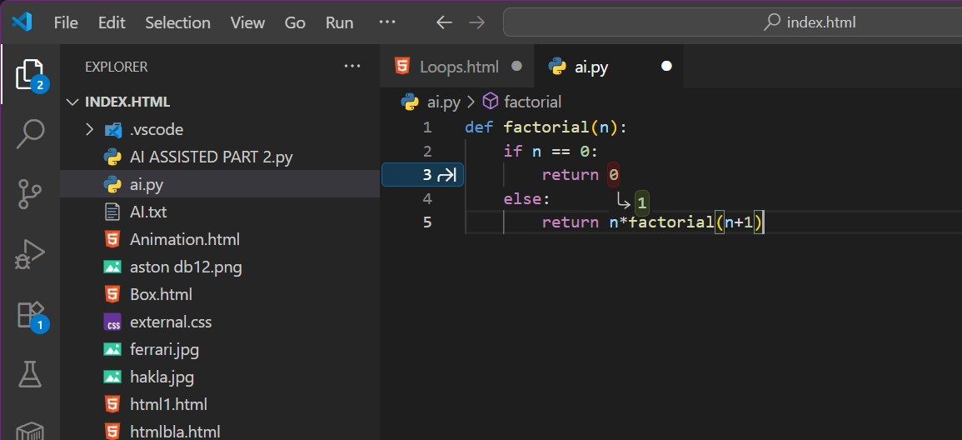

Prompt given to correct the code:

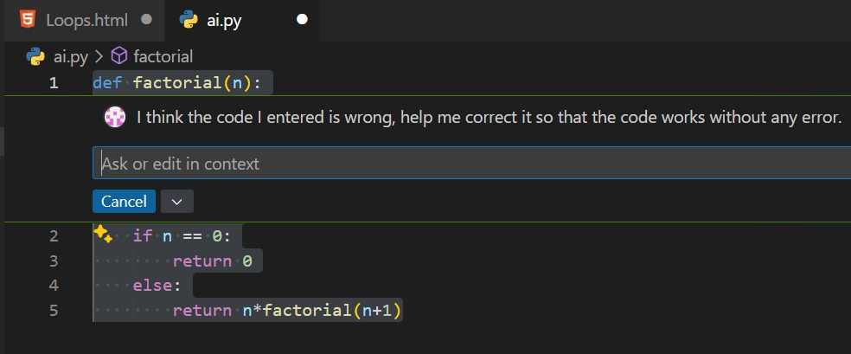

Output (Corrected Code):

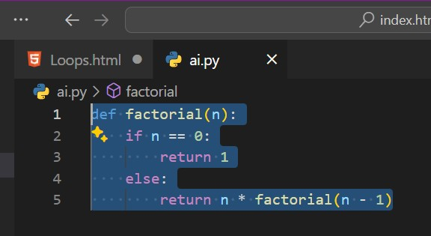

TASK #2

Input (Buggy Code):

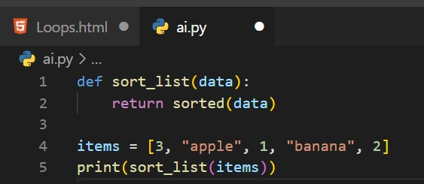

Prompt Given:

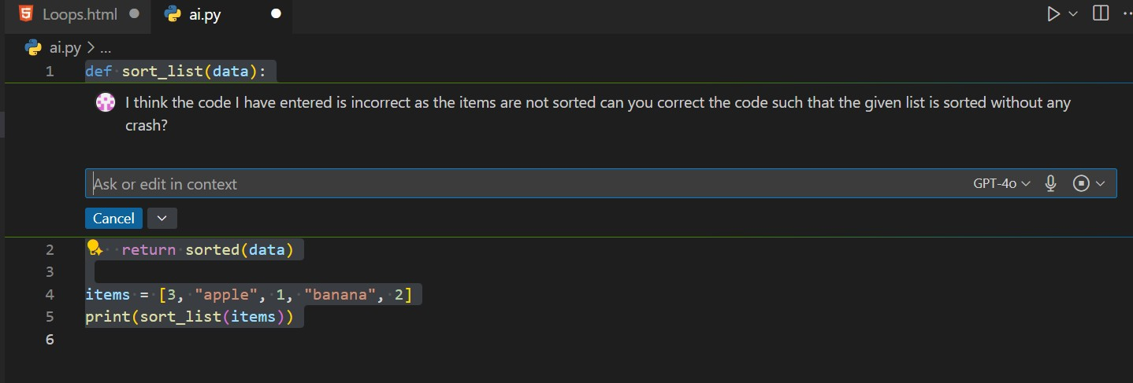

Output (Corrected Code):

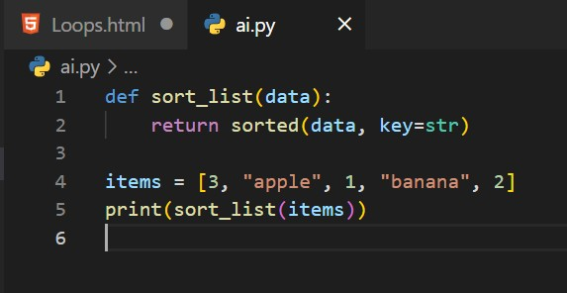

Task #3

Input (Buggy Code):

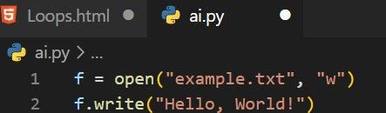

Prompt Given :

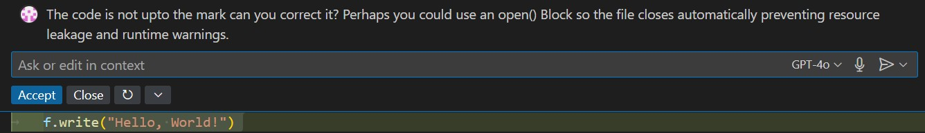

Output (Corrected Code):

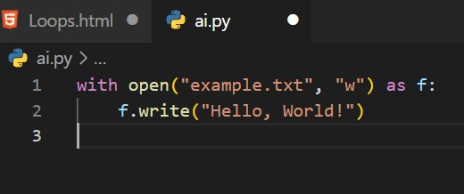

Task #4

Input (Buggy Code):

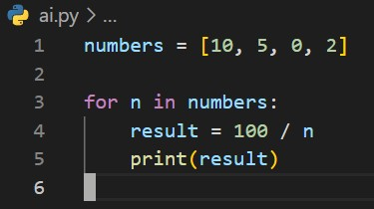

Prompt Given:

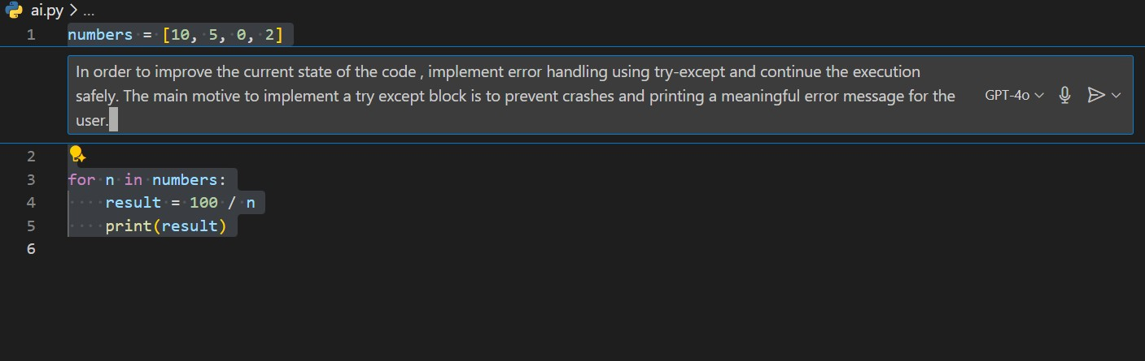

Output:

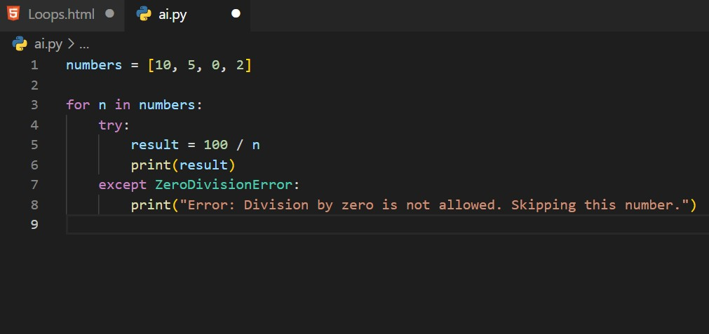

Task #5

Input (Buggy Code):

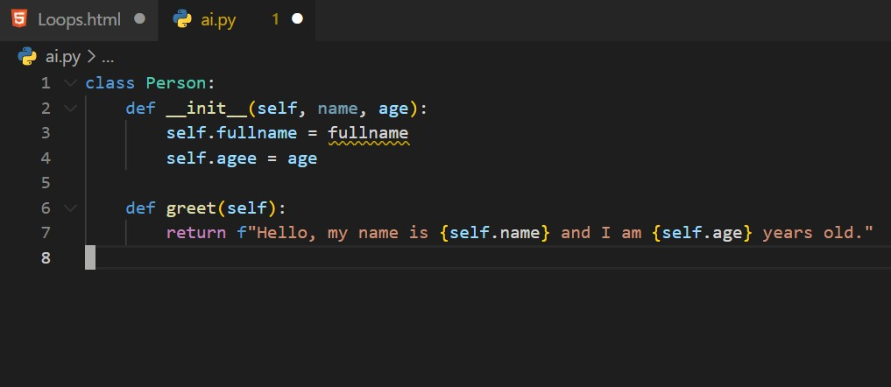

Prompt given:



Output:

